A2202-Asia-China-Shang-Jue-Chüeh-Taotie Mask-Ritual Inscription-Bronze-1300-1050 BCE

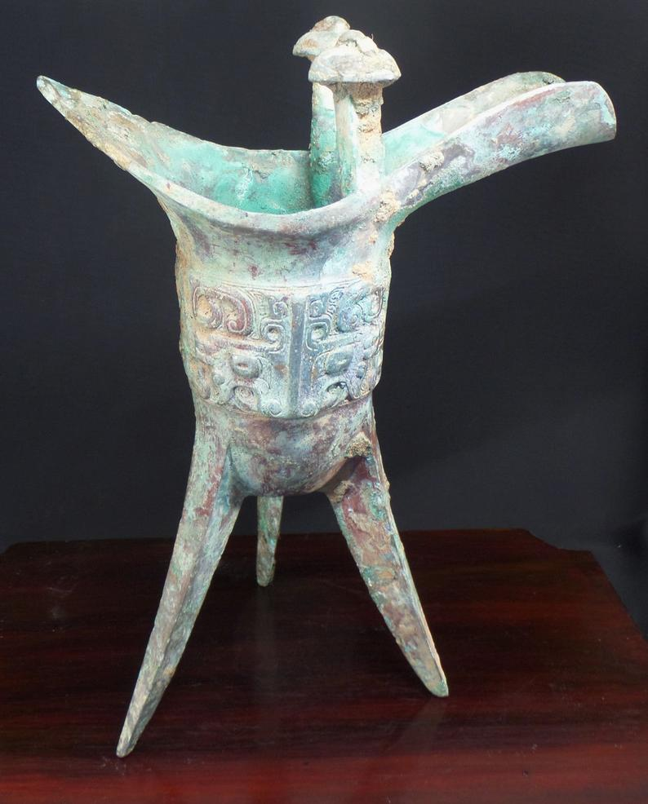

Fig. 1. China-Shang-Jue-Chüeh-Taotie Mask-Ritual Inscription-Bronze-1300-1050 BCE

Case No.: 5

Accession No.

Formal Label: China-Shang-Jue-Chüeh-Taotie Mask-Ritual Inscription-Bronze-1300-1050 BCE

**Display Description:**

The jue (chüeh, WG) is a type of ancient Chinese pitcher-like containers used for dispensing wine. The jue evolved from a pottery version in the Longshan culture (c. 2500–2000 BCE) during the late Neolithic Period. Its bronze version evolved in the Shang (c. 1600–1046 BCE) and early Zhou (1046–256 BCE) dynasties. The rim flairs into a U-shaped spout (with capped pillars at its base) on one side and a pointed tail, or handle, flaring out from the opposite side. A taotie, or animal spirit mask, is commonly found on either side of the body as a fierce looking mythological creature. It is cast in relief on this jue is called a “T’ao-t’ieh,” a zoomorphic beast that first appeared in Chinese mythology during the Hongshan Culture (3500 BCE—2100 BCE) and was thought to be the 5th of the Nine Sons of the Dragon. Little is known of the ancient meaning of the Tao-tie. The famous Tao-Tie is believed to have been a grand spirit monster that was thought to drive away evil spirits and protect the owner from harm. The extended eyes were thought to scare away evil spirits and the mouth could “devour one’s enemies” in a single gulp. The high-relief ridge that runs vertically down the wine pouring vessel is the Tao-tie’s nose.

  Some experts believe that the mysterious Tao-tie has something to do with the death and the after world, as its image is commonly found on the vessels used for sacrifices. While other experts believe that the Tao-tie was meant to guard the entrance to the after world and to keep out evil spirits. The Tao-Tie cast into this wine vessel is late Shang Dynasty period correct and matches perfectly the examples on display at the Smithsonian's Freer & Sackler Galleries website and other fine museums worldwide.

The fantastic Tao’tie mask is magical in itself as it contains an optical trick. At first glance, one can see the elements of the face, such as the eyes, horns, and jaws. However, when one covers up half of it, there appears to be two creatures (dragons) that meet in profile at the center. Each horn, eye, and jaw belongs to a separate being whose body stretches out into lower claws and an upper tail. One cannot see both at the same time.

Accession Number:

**LC Classification:**

Date or Time Horizon: 1300-1050 BCE

Geographical Area: **Anyang, China**

**Map:**

**GPS coordinates:**

Cultural Affiliation:

Medium: bronze

Dimensions: H 7.5 in (192 mm) high; W 6 in (150 mm)

Weight: 1.38 lbs; 627 gm

Condition:

Provenance:

This bronze Jue was probably discovered by farmers in 1938-1945 from the site of Anyang, Honan, an enormous site known from oracle bone records as the last capital of the Shang dynasty. Excavations had begun in 1928 but were interrupted by World War II, hence the farmers' findings in their fields in 1938-1945. The site is divided into five zones: buildings; workshops, foundries, kilns and an immense royal graveyard of enormous tombs. The city was surrounded by fields from which the food supply came.

Estimated Auction Value: $65,000--$80,000. On September 17, 2013, one famous auction house in New York estimated that a similar ancient jue would sell for $100,000 to $150,000.

|  |
| --- |
|  |

On Oct 23, 2017 , 4:08PM a similar example sold for US $51,250.00 Sequim, Washington, US, [houghton-usa](http://www.ebay.com/usr/houghton-usa?_trksid=p2047675.l2559) ([1415](http://feedback.ebay.com/ws/eBayISAPI.dll?ViewFeedback&userid=houghton-usa&iid=263225389787&ssPageName=VIP:feedback&ftab=FeedbackAsSeller&rt=nc&_trksid=p2047675.l2560))

Discussion: This bronze Jue was designed to stand on tall, thin, tripod legs to both heat and then serve warm wine to the aristocracy of ancient China’s upper class over 3,000 years ago. This Jue is surmounted by a pair of posts capped by mushroom tops with sunken whorl patterns, all raised on a leiwen ground of cloud swirls. Both the inner and outer surfaces are thickly covered with a pale, blue-green oxidation patina from the surrounding soil. This “copper alloy” may contain other elements (such as tin, lead, zinc, iron, and arsenic) which were added to the copper to form different strengths of bronze. Ancient bronze artifacts such as this vessel are probably about 80% copper and 20% tin, while modern bronze is closer to 88% copper and 12% tin. Close examination with a microscope under natural and black light reveal it to be have been cast by hand in a ceramic mold, with original signs of weathering and ground contact. One interesting property of bronze is that once it has oxidized superficially, a copper oxide (copper carbonate ) s formed on the surface and essentially protects the object from further damaging corrosion.

  When serving the heated wine, the server would have held vessel by the two, top posts or finials, because the lower part of the bronze Jue would have been very hot from heating over a fire. Decorative elements, skill, craftsmanship, and a lot of time went into the process to create this very expensive wine cup which was reserved only for the very wealthy in ancient China 3,000 years ago.

Bronze vessels, such as this Jue, were made to honor royal ancestors and as offering to the Gods.  This Jue may have been dedicated by a son to his father.  As early as the Shang dynasty, complex, beautifully decorated vessels for food and wine were placed in the tombs of the deceased to invoke blessings from the ancestors to the living.

**References:**

**Material: Cast bronze (copper-tin alloy)**

**Size: Weight:      1.38 lbs. (627 gr)**

**Origin: Anyang, China**

**Dynasty: Shang Dynasty**

**Est. Date: 1200—1100 BCE**

**Description:**

**This ancient Chinese Ritual Bronze Wine Vessel (called a *Jue* in Chinese) stands about 7.5" tall x 6" wide (19.2 cm tall x 15 cm wide). It was designed to stand on tall, thin, tripod legs to both heat and then serve warm wine to the aristocracy of ancient China’s upper class over 3,000 years ago. This Jue is surmounted by a pair of posts capped by mushroom tops with sunken whorl patterns, all raised on a *leiwen* ground of cloud swirls. Both the inner and outer surfaces are thickly covered with a pale, blue-green oxidation patina from the surrounding soil. This “copper alloy” may contain other elements (such as tin, lead, zinc, iron, and arsenic) which were added to the copper to form different strengths of bronze. Ancient bronze artifacts such as this vessel are probably about 80% copper and 20% tin, while modern bronze is closer to 88% copper and 12% tin.** **Close examination with a microscope under natural and black light reveal it to be have been cast by hand in a ceramic mold, with original signs of weathering and ground contact.** **One interesting property of bronze is that once it has oxidized superficially, a copper oxide (copper carbonate ) s formed on the surface and essentially protects the object from further damaging corrosion.**

**When serving the heated wine, the server would have held vessel by the two, top posts or finials, because the lower part of the bronze *Jue* would have been very hot from heating over a fire. Decorative elements, skill, craftsmanship, and a lot of time went into the process to create this very expensive wine cup which was reserved only for the very wealthy in ancient China 3,000 years ago.**

**Bronze vessels, such as this Jue, were made to honor royal ancestors and as offering to the Gods.  This Jue may have been dedicated by a son to his father.  As early as the Shang dynasty, complex, beautifully decorated vessels for food and wine were placed in the tombs of the deceased to invoke blessings from the ancestors to the living.**

**Provenience:**

**Iconography**

***Tao-tie* Dragon**

**The fierce looking mythological creature cast in relief on this *jue* is called a *“T’ao-t’ieh,”* a zoomorphic beast that first appeared in Chinese mythology during the Hongshan Culture (3500 BCE—2100 BCE) and was thought to be the 5th of the Nine Sons of the Dragon. Little is known of the ancient meaning of the *Tao-tie*. The famous *Tao-Tie* is believed to have been a grand spirit monster that was thought to drive away evil spirits and protect the owner from harm. The extended eyes were thought to scare away evil spirits and the mouth could “devour one’s enemies” in a single gulp. The high-relief ridge that runs vertically down the wine pouring vessel is the *Tao-tie’s* nose.**

**Some experts believe that the mysterious *Tao-tie* has something to do with the death and the after world, as its image is commonly found on the vessels used for sacrifices. While other experts believe that the *Tao-tie* was meant to guard the entrance to the after world and to keep out evil spirits. The *Tao-Tie* cast into this wine vessel is late Shang Dynasty period correct and matches perfectly the examples on display at the Smithsonian's Freer & Sackler Galleries website and other fine museums worldwide.**

**The fantastic *Tao’tie* mask is magical in itself as it contains an optical trick. At first glance, one can see the elements of the face, such as the eyes, horns, and jaws. However, when one covers up half of it, there appears to be two creatures (dragons) that meet in profile at the center. Each horn, eye, and jaw belongs to a separate being whose body stretches out into lower claws and an upper tail. One cannot see both at the same time.**

**Bronze Sacrificial Vessels in Ancient China**

**A skilled craftsman made this wine cup during what is called the Anyang Period of the Shang Culture, which lasted from about 1300 BC to 1030 BC. This ritual bronze vessel would have held rice or millet wine as a sacrifice to the Gods to honor the Spirit of an elite member of Shang society as he journeyed towards the afterlife—Heaven—or “*Tien*” in Chinese.**

**Originally cast as a spectacular ritual wine vessel for a high ranking member of the Shang dynasty aristocracy, it is outstanding for its details, the cast inscription/dedication, the quality of its decoration, and the rich azurite-blue patina that is so coveted by collectors of ancient bronzes.**

**The stylistic and technical advances in casting ritual, bronze vessel, as well as the dedication cast into the sides of the wine warming cup, suggest that piece was crafted during the Anyang Period, which is also called the High Yinxu phase of the powerful Shang Dynasty. This style was popular from the 13th to 11th century BC.**

**In ancient China, bronze vessels played an important role in ceremonies and rituals for rulers and high officials. The ritual books of ancient China minutely describe who was allowed to use what kinds of sacrificial vessels and in what size and quantity. Some bronze vessels have been discovered that are over 5 feet high and weigh as much as 4 tons!**

**Bronze production was carefully controlled by the emperor and bronze vessels were meant only for the elite aristocracy and their immediate families. The Chinese inscribed all kinds of bronze items with three main motif types: demons, symbolic animals, and abstract symbols**

**The creation of magnificent bronze vessels was highly labor-intensive, and therefore its use was confined to that of the most important rituals of ancient Shang and Zhou kings and aristocrats. The oldest Shang dynasty vessels were used in rituals centered on the sacrificial offering of food and wine to ancestors. Like elaborate banquets for the dead, foods which included meats and grains as well as rice or millet wine and sacrificial water were prepared and presented in bronze vessels and then ritually offered at family altars, often located in a separate structure within a family compound. As British scholar, Jessica Rawson, explains:**

***“These were essentially family ceremonies in which both the dead and the living took part. The dead remained an integral part of everyday society, requiring the kind of attention also given to living members of the family. The banquets or rituals were a show of respect to the dead so as to ensure that they would help their descendants by interceding on their behalf with the gods and spirits. Without help from the dead, and a proper acknowledgement of their role, human affairs might fail and their descendants suffer.”***

**This was especially so of kings, whose ancestors not only had the power to affect the fortunes of their descendants, but were semi-godlike, having power and influence over the entire population as well. Thus the most elaborate rituals-- more like ceremonies of state than the private rituals held by aristocratic families-- were performed by ancient kings. Highly decorated bronze vessels created in sets played a leading role in these rituals-- containing sacrifices and hosting their preparation.**

**The Chinese ancestors believed that the design of the ornaments could communicate with divinities and frighten demons as well. Therefore, to enshrine the bronze ware in the temple or tomb would do something good to them – either bring them good luck or ward off evil spirits.**

**China: Shang Dynasty (about 1500-1050 BC)**

**The Shang dynasty is important because it was the first Chinese dynasty to have left written records and those records reveal the cultural choices that provided the subsequent Zhou and Han dynasties with their historical background.**

**The manufacture of bronze is what distinguishes the Shang period from the earlier Neolithic period in China. Historical records mention another ruling group, the Xia, as preceding the Shang, but no archaeological site has been found yet to prove this, so it remains a matter of speculation. The Shang period is usually divided into three phases:**

**1.    Erlitou (about 1650-1500 BC),**   
  
**2.    Erligang (about 1500-1400 BC) and,**  
  
**3.    Anyang (after around 1300 BC), also known as the Yinxu phase.**   
  
**Based on a comparison to known examples in museums to height, style, and inscriptions, this jue dates to approximately the Anyang period.**

**The Shang warlords and kings are recognized by their fine, cast bronzes, particularly their bronze vessels in which food and wine were offered to the ancestors. The earliest known bronzes have been found at Yanshi Erlitou in the northern province of Henan. A site with a city located at the modern town of Zhengzhou was probably constructed by about 1500 BC. A massive city wall, specialized workshops and buildings of differing standing, all indicate a highly organized and stratified society. At this stage, the influence of the Shang must have been very great, as bronze vessels in the metropolitan style (in terms of shape and decoration) have been found at widely separate sites across Shaanxi, Anhui, Hubei and Henan.**

**The major site of the late Shang period was at Anyang. Notable discoveries include large palace buildings, workshops, burials both of kings and nobles, and deposits of oracle bones. The large numbers of inscribed oracle bones and bronze inscriptions found at Anyang are China's earliest known examples of writing. They also serve to validate many later historical records, as a number of the inscriptions include the names of kings.**

**It was at Xiaotun that perhaps the most impressive of the bronze-casting industry of the royal Shang kings ordered the production of fine, ritual, bronze vessels to communicate with the Shang ancestors and the gods in Heaven, especially the supreme god Di. Bronze production was strictly controlled by the royal family, and the elite members of Shang’s upper class were strictly limited as to the type and number of ritual bronzes that they could take to the afterlife with them in their tombs.**

**REFERENCES**

1. **Museum of Chinese History, Beijing**
2. ***The Ancestral Landscape*, David N. Knightley, 2000**
3. ***The Great Bronze Age of China*, edited by Wen Fong, MET, 1980**
4. ***Changhua Annals of the Republic of China* (1911–1949)**
5. **British Museum, Jessica Rawson**
6. **Smithsonian Museum, Sackler & Freer Gallery, WDC**
7. **MET, New York**